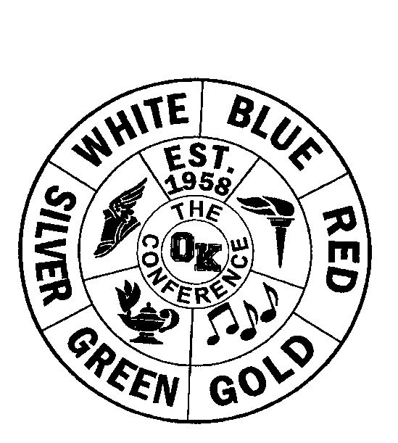
OK Conference All-Conference

Sport: Girls Bowling

Division: Silver

School Year: 2020-21

AD Name: Adam Valk

1ST TEAM HONORABLE MENTION

Name/Gr School Name/Gr School
Summer Thomas | Belding |  | Daelyn Kaufman | Kelloggsville
Mackenzie Griffen | Lee |  | Alayna Ryan | Hopkins
Kennedy Gill | Hopkins |  | Abby Way | Sparta
Abby Simpson | Hopkins |  | Rylie Dettwiler | Comstock Park
Leah Helder | Hopkins
Aliyah Dines | Sparta
Kendyl Bjorkman | Sparta
Ashley Hunter | Comstock Park

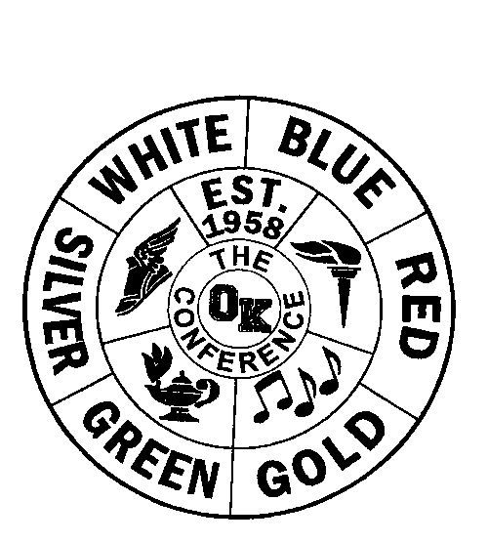
OK Conference Final Standings

Sport: Girls Bowling

Division: Silver

School Year :2020-21

AD Name: Adam Valk

Regular Season Conference Tournament
School Record Pts. Place School Pts. Place
Hopkins | 9-1 | 9 | 1st |  | Hopkins | 5 | 1st
Sparta | 8-2 | 8 | 2nd |  | Sparta | 4 | 2nd
Comstock Park | 6.5-3.5 | 6.5 | 3rd |  | Comstock Park | 3 | 3rd
Belding | 2.5-5.5 | 2.5 | 4th |  | Belding | 2 | 4th
Lee | 3-6 | 3 | 5th |  | Kelloggsville | 1 | 5th
Kelloggsville | N/A | 0 | 6th |  | Lee | 0 | 6th

Final Standings
School Place Pts.
Hopkins | 1st | 14
Sparta | 2nd | 12
Comstock Park | 3rd | 9.5
Belding | 4th | 4.5
Lee | 5th | 3
Kelloggsville | 6th | 1

